The need for urgent action emphasized at Colorado River conference
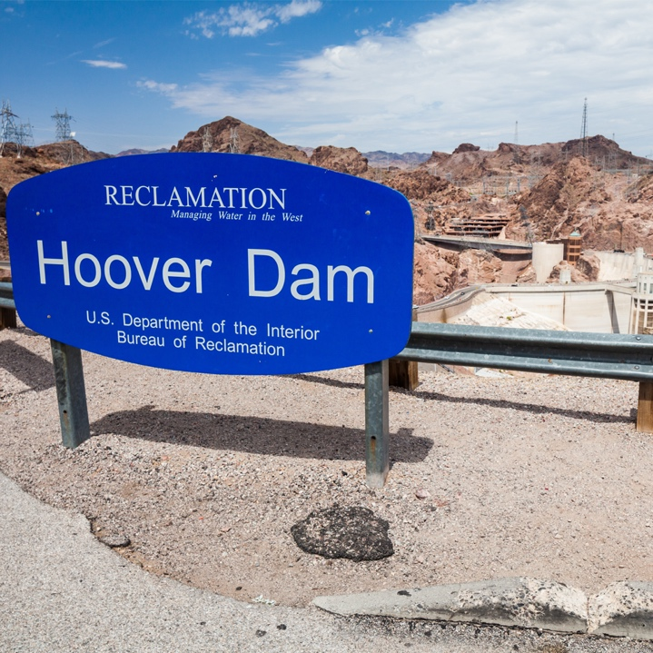
State and federal water leaders voiced urgency for decisive action to address the dire situation on the Colorado River at last week’s Colorado River Water Users annual conference in Las Vegas. Still, we remain without a specific plan of attack from Reclamation or consensus among the Basin States. What was made clear as federal, state, and local representatives gathered was that within a year or two, both Lake Powell and Lake Mead could be at deadpool.

The reality is that the Colorado River is in crisis and is not producing the same amount of water it did in the previous century. Instead of 15 million acre-feet of water each year, the River is only yielding closer to 12 million acre-feet. Projections show that due to the combination of drier climate and hotter temperatures, the Colorado River may only generate between 9 and 11 million acre-feet of water in the near future.

This means that time and hydrology are not on our side and all Colorado River water users have only one choice to avert disaster - significantly reduce how much water they take from the River. This will only work if every user in every sector in every Colorado River Basin state is willing to accept cuts. Unfortunately, many are reluctant to face the hydrologic math. They are clinging to how they have been able to use the water in the past, legal priorities, and some magical thinking, which will undoubtedly lead to a dry River benefitting no one.

The U.S. Bureau of Reclamation, which is responsible for managing the River, acknowledged again that the system is approaching a tipping point. Without action, they cannot protect the River and the millions of Americans who rely on this critical resource. To avoid a catastrophic collapse of the Colorado River system, water use in the basin must be reduced. If no definitive plan comes from the Basin States, Reclamation has said they will take action to prevent a Colorado River system crash.

Reclamation has requested comments by December 20, 2022, on its process to revise the current operational guidelines used to manage the River so that they will have the authority to take further action. They are trying to put together updated operational guidelines for Lake Powell and Lake Mead within the next three months, an unprecedented fast-track for the federal government. Hopefully, this process is not taking place too late to make the needed impact.

The ten AMWUA cities understand the seriousness of the Colorado River situation. They are urging Reclamation to be prepared to act rather than hope that the seven Basin States can put together a consensus plan. However, any action must include equitable demand reductions among all users and sectors are necessary to stabilize the Colorado River system and cannot fall on only Arizona. Reclamation should consider utilizing the relative volumes and/or proportions of evaporation and system losses attributable to delivering water to Arizona, California, and Nevada in determining the basis for additional reductions.

Reclamation and others have been raising the focus on health and safety in determining reductions in Colorado River water. As municipal water providers that are ultimately responsible for serving water directly to end users, the AMWUA cities are on the front lines of ensuring public health and safety for their communities. AMWUA emphasized to Reclamation that when integrating public health and safety into Colorado River operational decision-making, it is critical to understand that public health and safety cannot be reduced to an arbitrary allotment for minimum drinking water needs. Schools, hospitals, businesses, high-tech industries, manufacturers, military, and more need water to ensure that their critical functions of national importance are able to continue.

Whatever course of action Reclamation takes, it will be difficult and unpopular since it will force all Colorado River water users to face the stark reality of having to live with less water. The fact is that unless some serious decisions are made and fast, the crisis will become dire. And taking no action is not an option since that will undoubtedly lead to the unacceptable and harsh reality of a dry River. We all have benefited from the River, so it is now our turn to protect this lifeblood for the West.

For over 50 years, Arizona Municipal Water Users Association has worked to protect our member cities’ ability to provide assured, safe, and sustainable water supplies to their communities. For more water information, visit www.amwua.org.

