In the heat of the summer, we are reminded of the importance of having reliable water
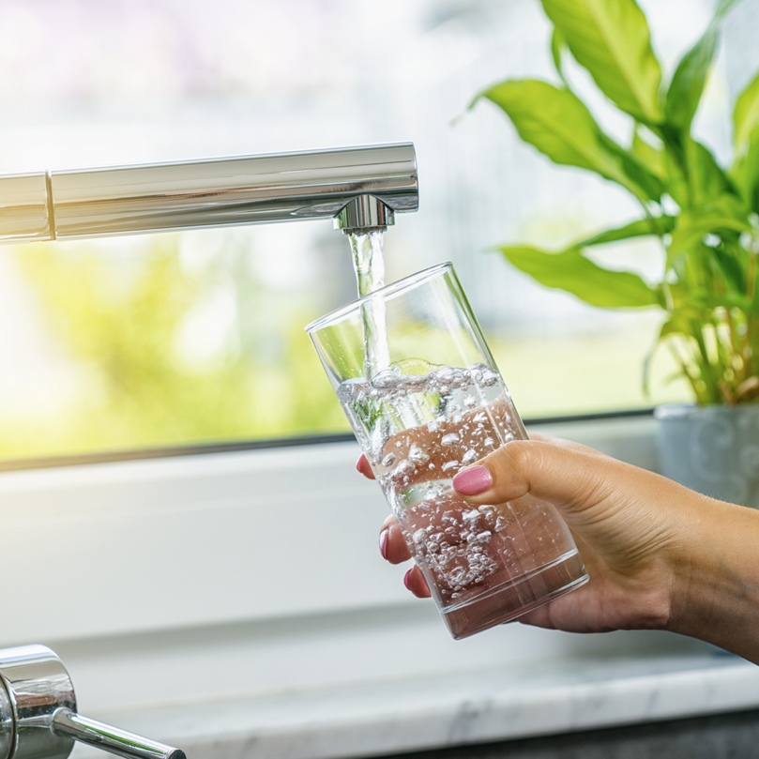
Summer in the desert brings many challenges. The intense temperatures and lack of precipitation can leave everyone and everything feeling a bit battered. Luckily, having reliable access to safe water at our taps enables us and our landscapes to remain hydrated, which is critical to our survival and a good reminder of why water is called our most precious resource. However, ensuring we have continued access to quality water is not a simple task, yet it remains the highest priority for the ten AMWUA cities.

Water providers are among the most regulated industries in the country and are held to the highest standard. Over the course of a year, Valley water utilities perform millions of tests and measurements to ensure safe water treatment and distribution systems. Each of the AMWUA cities has an aggressive water quality program with a dedicated team of chemists, technicians, and specialists who head out daily, regardless of the temperature, to the various water service areas to test for hundreds of substances using state-of-the-art equipment and laboratories to make sure your water consistently meets the safe drinking water standards. This means significant money, time, and effort are focused on water quality.

With multiple water sources utilized by the AMWUA cities, it’s important to note each supply requires a different level of treatment due to the varying particles accompanying each of them. Addressing those treatment challenges is why the cities have and continue to invest in their vast infrastructure and advanced treatment facilities so that there is always enough safe and regulated water for all of us to use whenever we need it while striving to keep water affordable for households throughout the Valley.

In addition to the treatment process and continual monitoring and testing of water samples, each municipality must provide regular reports on their water quality detailing each sample. Each city provides an annual water quality report to its customers this time of year, demonstrating the reliability of our safe drinking water and significantly reducing the danger of a major water contaminant crisis.

So remember, your water utility works hard around the clock, indoors and out, even in our extreme weather and regardless of temperature, to ensure high-quality water is there for you every day. Quality water is available to cool off, make your favorite cup of tea or morning coffee, or cook your favorite meal. Most importantly, it is always accessible to ensure the health and safety of ourselves, our loved ones, and our communities, which is especially important during our intense heat waves.

Our municipalities consistently meet all the safe drinking water standards set by the Environmental Protection Agency (EPA), the Arizona Department of Environmental Quality (ADEQ), and the Maricopa County Environmental Services Department. These requirements fall under the Safe Water Drinking Act, bringing accountability and safeguarding high water quality standards.

For over 50 years, Arizona Municipal Water Users Association has worked to protect our member cities’ ability to provide assured, safe, and sustainable water supplies to their communities. For more water information, visit www.amwua.org.

